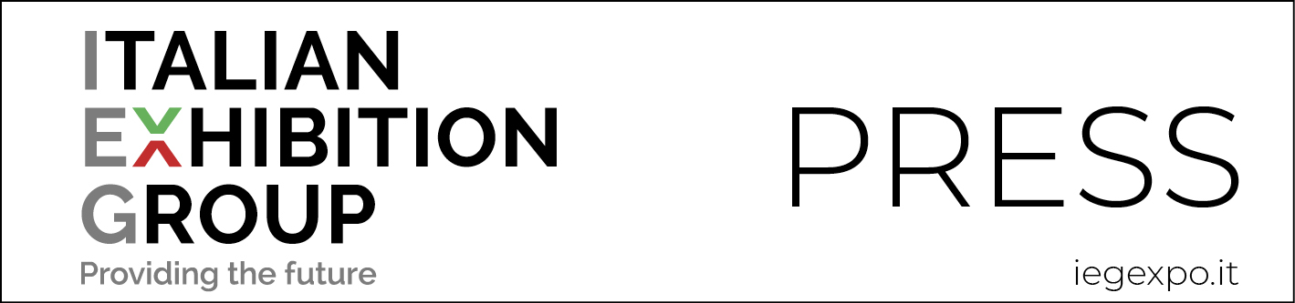

press release
(English translation)

IEG READY TO RE-START IN TOTAL SAFETY

Green pass to access the Expo Centre;
and the new Safe Travel service for international and safe customer mobility
organized with the specialist Studio Arletti&Partners

Rimini, 22 July 2021 – Green Pass and Safe Travel so that exhibitors and visitors are guaranteed the highest possible level of security.

IEG - Italian Exhibition Group S.p.A., after having been the first in Italy to develop the SAFE BUSINESS protocol in April 2020 and having then followed up with numerous initiatives aimed at global security, is now adding further elements to ensure the safety of the people and companies attending the shows.

GREEN PASS FOR ENTRY INTO THE EXPO CENTRE
Please note that in accordance with current legislation and with the aim to protect companies, visitors, suppliers and staff, all those entering the Expo Centres while trade shows are underway, will be required to be in possession of a “Green Pass” or a negative test taken within 48 hours (those without this pass will be able to do a rapid antigen test at a special price at the Expo Centre entrance upon prior on-line reservation).
Those from non-EU areas must provide a vaccination document in the English language showing the type of vaccine received, which must be EMA approved.
The first trade shows to be involved will be Macfrut in Rimini and Vicenzaoro in Vicenza. “The aim,” explains Corrado Peraboni, CEO of IEG, “is to guarantee our exhibitors/visitors with Covid-free halls, a place where the only thing those inside need to worry about is doing business. The request for this measure has come loud and clear from the companies, particularly the multi-nationals, that want to be able to guarantee maximum safety for their collaborators who will be attending the shows once they open in September. It is no coincidence that the Green Pass is foreseen as a requirement by the vast majority of European trade show organizers.”

SAFE TRAVEL
In regard to safety, sharing information so that every difficulty in terms of mobility can be overcome, is a precious asset to offer exhibitors and visitors. With this mission, yet another first in our country, Italian Exhibition Group will offer its own foreign guests a new opportunity to be aware of the rules for entering and sojourning in Italy. This will prove even more valid as the pandemic situation continues to evolve. The information offered comes from an agreement signed with Studio Arletti&Partners, a firm specialized in global mobility which, since 1998, has been assisting companies and private individuals in matters of foreign postings, covering every aspect of consultancy relating to global mobility.
In the expo centres where IEG operates, a timely, constant, agile and informative assistance on the regulations and compliances that international visitors and exhibitors should abide by in order to enter Italy will be provided. A service that regards arrivals by plane, train, bus or car and which indicates the national requirements and those that the AUSL, Italian Health Service, may outline in the various territories where the shows are to be held.
Customers will receive the information by completing a simple form available on the shows’ websites. The only information required will be place of departure, international connection locations, if any, and place of arrival. The response will also provide territorial medical assistance contact numbers.
The system will be updated daily in regard of any changes in regulations thanks to a pool of professionals specialized in legal disciplines. Should customers require any further assistance, IEG, together with Studio Arletti, will be able to provide customized services.

15 MONTHS OF SAFETY INITIATIVES
The SAFE BUSINESS BY IEG protocol, devised in April 2020, has been extended with adhesions to AEFI (Italian Exhibition and Trade Fair Association) and UFI (The Global Association of the Exhibition Industry) protocols and IEG’s attainment, for all its venues, of the GBAC STAR™ facility accreditation, the global certification programme regarding the correct practices, procedures and systems to meet the international standards of cleanliness, disinfection and infectious disease prevention for facilities and staff promoted by the Global Biorisk Advisory Council.

IEG facilities are the only ones in Italy to be able to boast of having this accreditation.
Last May, IEG voluntarily adhered to the Confcooperative Romagna, Confindustria Romagna and Legacoop Romagna project for vaccinating its employees against Covid thanks to the inter-company hub set up in the Romagna regional territory. Activities accompanied by a constant track and trace campaign: between June 2020 and May 2021, IEG has carried out, on a voluntary basis, 900 serological tests and screening swabs on the human resources at its four venues.

PRESS CONTACT ITALIAN EXHIBITION GROUP media@iegexpo.it
head of media relation & corporate communication: Elisabetta Vitali
international press office coordinator: Silvia Giorgi

FOCUS ON ITALIAN EXHIBITION GROUP
Italian Exhibition Group (IEG), listed on the MTA (screen-based stock exchange) organised and managed by Borsa Italiana S.p.A., has built up over the years, through its Rimini and Vicenza venues, a position of domestic leadership in the organisation of trade fairs and conferences, and has developed its foreign activities - also through joint ventures with global or local organisers, in the United States, United Arab Emirates, China, Mexico, India - which have positioned it among the leading European operators in the sector.

This press release contains forecast elements and estimates that reflect the management’s current opinions (“forward-looking statements”), particularly regarding future management performance, realization of investments, cash flow trends and the evolution of the financial structure. For their very nature, forward-looking statements have a component of risk and uncertainty, as they depend on the occurrence of future events. The effective results may differ (even significantly) from those announced, due to numerous factors, including, only by way of example: food service market and tourist flow trends in Italy, gold and jewellery market trends, green economy market trends; the evolution of raw material prices; general macroeconomic conditions; geopolitical factors and evolutions in the legislative framework. Moreover, the information contained in this release, does not claim to be complete, and has not been verified by independent third parties. Forecasts, estimates and objectives contained herein are based on the information available to the Company as at the date of this release.

